**PRACTICAL 9:Mongodb**

**1.AIM:**

To understand how to use MongoDB

**2.WRITEUP**:

What is MongoDB?

MongoDB is an open-source document database and leading NoSQL database. MongoDB is written in C++..

**1.The use Command:**

MongoDB use DATABASE_NAME is used to create database. The command will create a new database if it doesn't exist, otherwise it will return the existing database.

Basic syntax of use command is as follows-

Use databasename;

**2.The createCollection() Method**

MongoDB db.createCollection(name, options) is used to create collection.

Basic syntax of createCollection() command is as follows −

db.createCollection(name, options);

**3.The insert() Method**

To insert data into MongoDB collection, you need to use MongoDB's insert() or save() method.

Syntax

The basic syntax of insert() command is as follows −

db.COLLECTION_NAME.insert(document);

**4.The find() Method**

MongoDB's find() method, explained in MongoDB Query Document accepts second optional parameter that is list of fields that you want to retrieve. In MongoDB, when you execute find() method, then it displays all fields of a document. To limit this, you need to set a list of fields with value 1 or 0. 1 is used to show the field while 0 is used to hide the fields.

**3.PRACTICALS**:

Use roshan

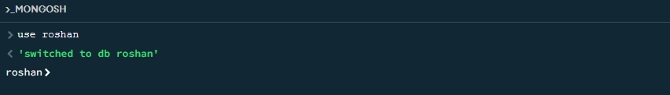

Db.createCollection(“Jinwoo”)

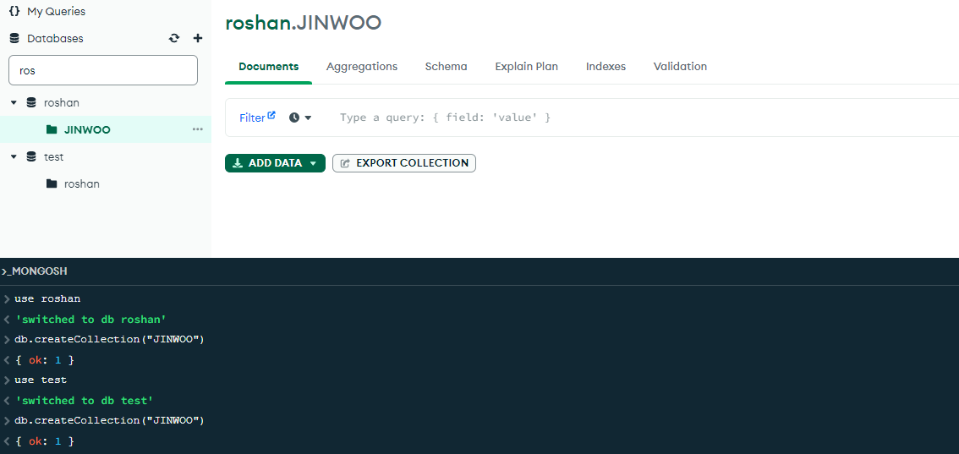

db.Jinwoo.insertOne({

title: ”Post Title 1”,

body: ”body of post.”,

category: ”News”,

likes: 1,

tags : [“news”,”events”],

date: Date()

})

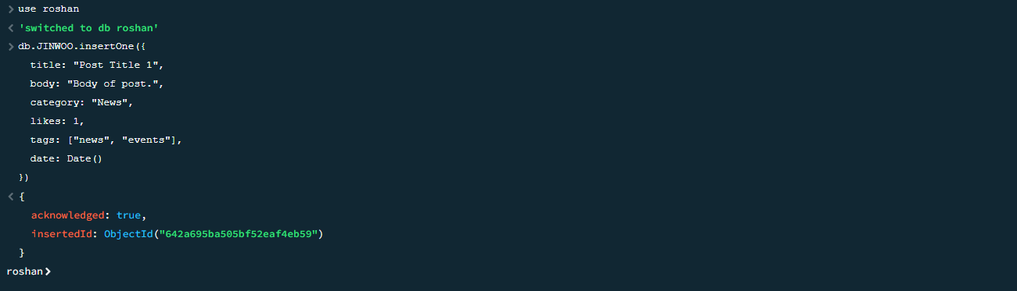

Db.createCollection(“Monarch”)

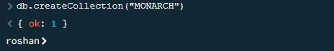

Db.monarch.insertMany([

{ title: ”Post Title 2”,

body: ”body of post.”,

category: ”Event”,

likes: 2,

tags : [“news”,”events”],

date: Date()

}

{ title: ”Post Title ”,

body: ”body of post.”,

category: ”Event”,

likes: 4,

tags : [“news”,”events”],

date: Date()

}])

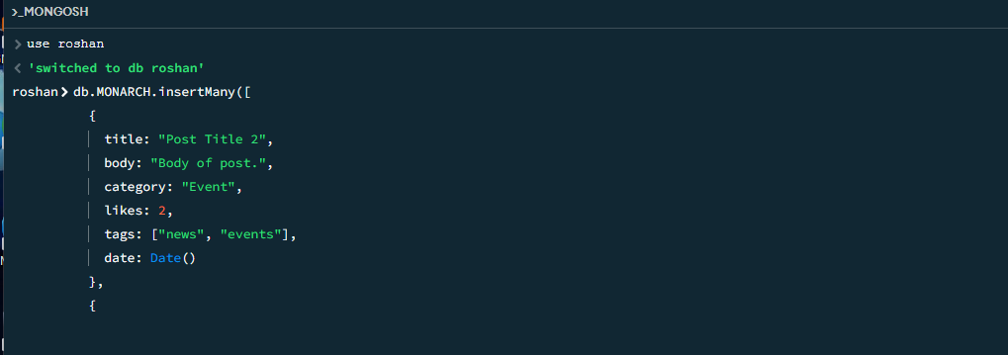

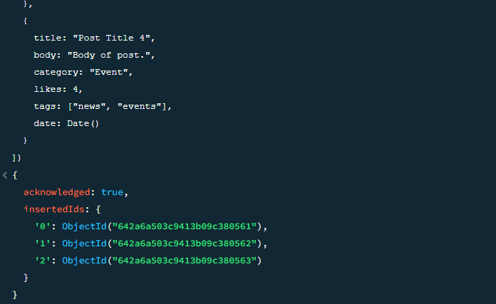

db.Jinwoo.find( {category: ”News”} )

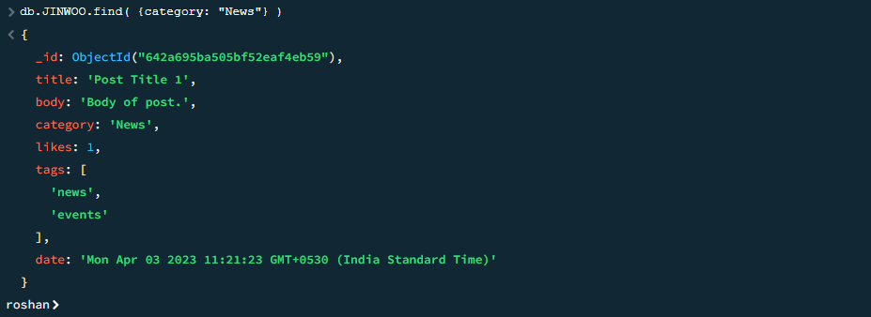  
db.Monarch.find({}, {title: 1, date :1})

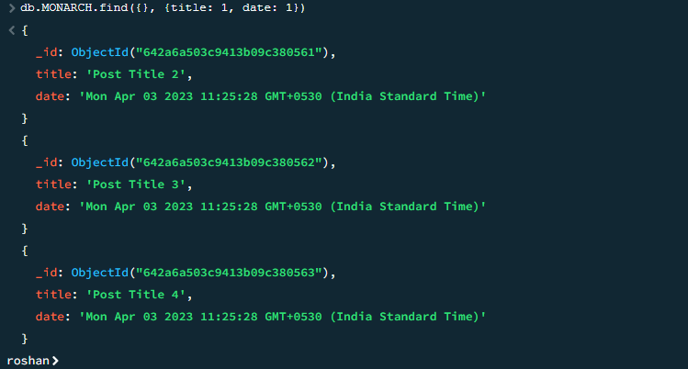

db.Jinwoo.findOne()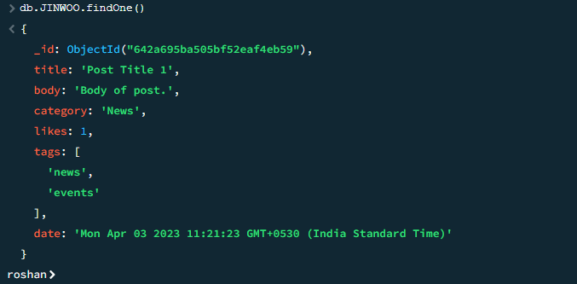

db.Jinwoo.find({},{KEY :1})

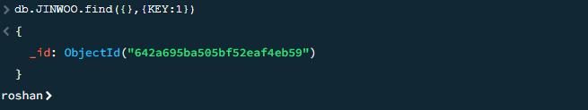

db.Jinwoo.find({},{“title”:1,_id:0})

